What’s MQTT “**Message Queuing Telemetry Transport”** Protocol?  
MQTT : MQTT is a standards-based messaging protocol, or set of rules, used for machine-to-machine communication. Smart sensors, wearables, and other Internet of Things (IoT) devices typically have to transmit and receive data over a resource-constrained network with limited bandwidth

for data transmission, as it is easy to implement and can communicate IoT data efficiently. MQTT supports messaging between devices to the cloud and the cloud to the device.

Lightweight and efficient

### **Scalable**

### **Reliable**

### **Secure**

### **Well-supported**

### MQTT protocolMQTT protocolWhat is MQTT and How It Works - YouTubeMQTT - Wikipedia

[What is MQTT? - MQTT Protocol Explained - AWS (amazon.com)](https://aws.amazon.com/what-is/mqtt/#:~:text=MQTT%20is%20a%20standards%2Dbased,constrained%20network%20with%20limited%20bandwidth.)

[MQTT Protocol | Message Queuing Telemetry Transport Protocol - javatpoint](https://www.javatpoint.com/mqtt-protocol)

Firebase Real-time Database

Store and sync data with our NoSQL cloud database. Data is synced across all clients in realtime, and remains available when your app goes offline.

Data is stored as JSON and synchronized in realtime to every connected client.

Realtime: Firebase Realtime Database uses data synchronization—every time data changes, any connected device receives that update within milliseconds.

Offline : Firebase apps remain responsive even when offline because the Firebase Realtime Database SDK persists your data to disk.

Accessibility : The Firebase Realtime Database can be accessed directly from a mobile device or web browser; there’s no need for an application server.

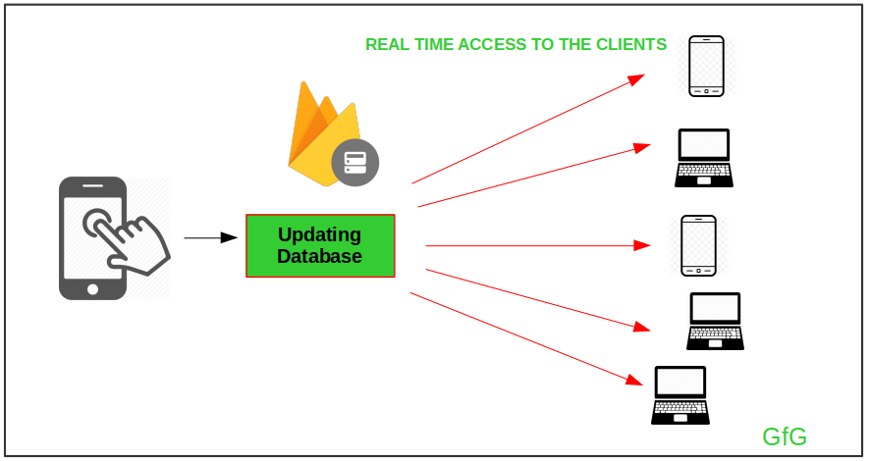

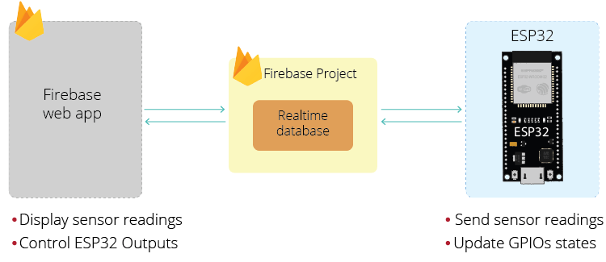

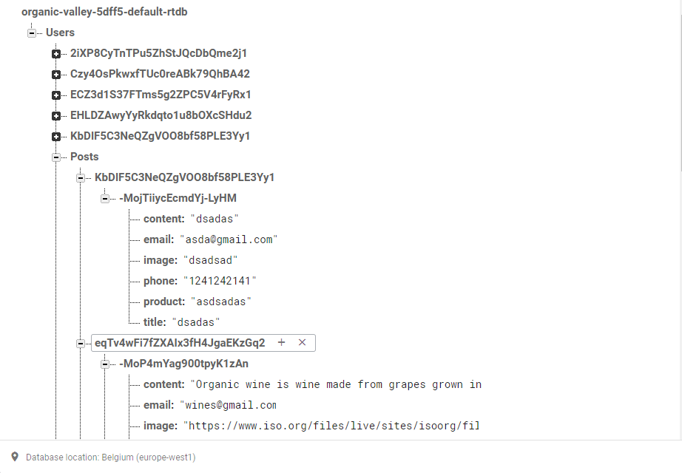

[Firebase Realtime Database (google.com)](https://firebase.google.com/docs/database)